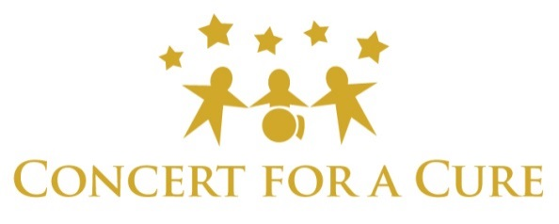
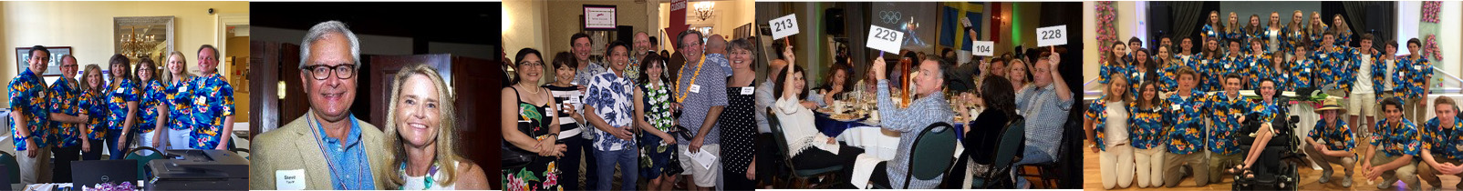

An Invitation for Sponsors
The 20th Annual Concert for a Cure is a Northern California fundraising event with one goal: Bring a cure for Spinal Muscular Atrophy. Proceeds from this event benefit Cure SMA, the leading SMA research organization. We need your help now to make a difference in the lives of thousands of families. We invite you to be a Sponsor for 20th Annual Concert for a Cure benefiting Cure SMA.
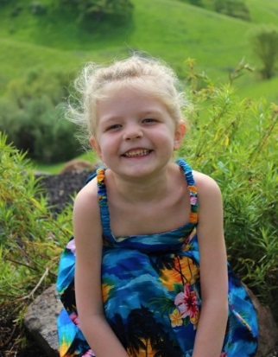
This exciting event has contributed over $2 million in funding for valuable research and family support programs through Cure SMA. This year’s dinner and auction event will draw 350 attendees from throughout the Bay Area!

Hosted by three families of children with SMA, the McHale, Dindzans and Barsotti-Dooling families, Concert For A Cure “Cheers to 20 Years” will be held on Saturday, May 9, 2020 at Diablo Country Club in Diablo, California. Please join us in what is sure to be a night full of memories, good times, and most importantly, hope.

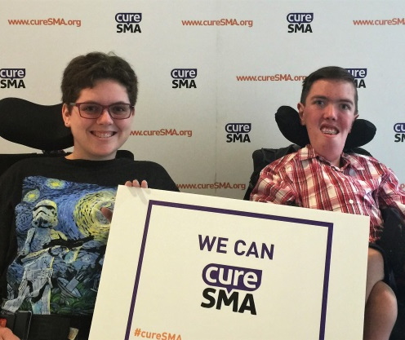
What is SMA?
Spinal Muscular Atrophy (SMA) is a neuromuscular disease from birth that robs infants the ability to crawl, swallow and even breathe. SMA affects every race and gender. Every 12 hours in the U.S. a child is born and diagnosed with SMA. More than 7 million Americans carry the gene that causes SMA, the number one genetic cause of death for infants.
We Need You!
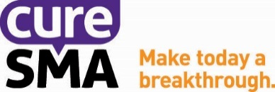
Your support is critical now more than ever before. Every day, our families wonder what could have been, had our children not been diagnosed with SMA. Every day, thousands more families across the world with children wonder when a cure will come for them. All of the money raised at the Concert for a Cure will benefit Cure SMA, a non-profit 501(c)(3) organization that funds the research necessary to develop a treatment and cure for our children. With your help, we will find a cure.

OVERVIEW OF SPONSORSHIP OPPORTUNITIES
Through Concert for a Cure, Cure SMA offers companies a partnership that will enhance positive corporate image while contributing to ongoing SMA research programs. Everyone will benefit from helping to raise awareness and finding a cure for Spinal Muscular Atrophy.

Our silent auction donations and sponsorships will generate a large portion of our event’s revenue. Please consider the highest possible contribution from your organization. To register as an event sponsor, please fill out the Sponsorship Enrollment Form, found within this packet.

Title Sponsor ($15,000)
- Includes 20 guest tickets for event
- Opportunity to provide a favor to each guest as they leave event
- Back cover full page ad/tribute in event program
- Access to exclusive cocktail area with company logo surrounding and signature cocktail
- Company prominently highlighted as Title Sponsor throughout event, and in all event press materials and public service announcements before and after event date*
- Two Social Media posts announcing sponsorship on Concert for a Cure Facebook page and Website
- Exclusive press release sent to San Francisco Bay Area media contacts announcing sponsorship collaboration
- Personal table service throughout the dinner / live auction
- Priority check-in / check-out
- Large Company sign displayed in event venue **
- Lead positioning of Company logo on front cover of 800+ event invitations*
- Company logo displayed on video played throughout the evening **
- Company logo displayed in event program **
- Special recognition during the event
- Company logo displayed on all email marketing materials, sent to audience of 1,500+ *
- Company logo and website link prominently displayed on event website

Diamond Sponsor ($10,000)
- Includes 16 guest tickets for event
- Full page ad/tribute in event program
- Company logo displayed prominently on event “Step & Repeat” welcome backdrop
- Company highlighted as Diamond Sponsor in all event press materials*
- Company sign displayed in event venue **
- Company logo displayed on 800+ event invitations*
- One Social Media post announcing sponsorship on Concert for a Cure Facebook page and Website
- Company logo displayed in event program **
- Special recognition during the event
- Company logo displayed on select email marketing materials, sent to audience of 1,500+ *
- Company logo and website link prominently displayed on event website
Platinum Sponsor ($5,000)
- Includes 10 guest tickets for event
- Half page ad/tribute in event program
- Company highlighted as Platinum Sponsor in all event press materials*
- Company sign displayed in event venue **
- Company logo displayed on 800+ event invitations*
- One Social Media post announcing sponsorship on Concert for a Cure Facebook page and Website
- Company logo displayed in event program **
- Special recognition during the event
- Company logo displayed on select email marketing materials, sent to audience of 1,500+ *
- Company logo and website link prominently displayed on event website
Gold Sponsor ($2,500)
- Includes 8 guest tickets for event
- Quarter page ad/tribute in event program
- Company logo displayed on select signage in event venue**
- One Social Media post announcing sponsorship on Concert for a Cure Facebook page and Website
- Company logo displayed in event program **
- Company logo displayed on select email marketing materials, sent to audience of 1,500+ *
- Company logo and website link displayed on event website
Silver Sponsor ($1,500)
- Includes 4 guest tickets for event
- Quarter page ad/tribute in event program
- Company logo displayed in event program**
- Company logo displayed on select email marketing materials, sent to audience of 1,500+ *
- Company logo and website link displayed on event website

* Subject to deadline of February 1, 2020
** Subject to deadline of March 15, 2020
Please note: In-Kind sponsors will receive recognition level at the value of their donated gift (Please fill out appropriate In-Kind Donation Form). Special sponsorship recognition is available for major donations of goods and services, such as food, beverage, and advertising, depending on the cash value of the donation.
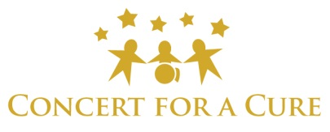
Sponsorship Enrollment Form

Primary Contact Name(s): ___________________________________________
Business Name (If applicable): _______________________________________
Address: _________________________________________________________________________________
City: _______________________________________ State: ________________ Zip: __________________
Phone: _________________________________________ Cell: _____________________________________
Email Address: ___________________________________ Website: _________________________________
Sponsorship Level  Title Sponsor ($15,000)  Diamond Sponsor ($10,000)  Platinum Sponsor ($5,000)  Gold Sponsor ($2,500)  Silver Sponsor ($1,500)  Ad | Tributes  Quarter Page - $150  Half Page - $275  Full Page - $400  Inside Back Page - $525  Inside Front Page - $600  Inside Front Cover Page - $600 | Payment Method  Check Enclosed Visa MasterCard American Express Discover  Credit Card Number:  ________________________________________________________  NAME ON CREDIT CARD: __________________  Expiration Date: __________________  Security Code: ________________  Billing Address (if different from above):_______________________________ ______________________________________________________________________________________________________________________________  Please make checks payable to: Cure SMA  (100% of net proceeds will benefit Cure SMA)
Sponsorship Commitment
I/we agree to pledge the total cash amount of $_____________ by March 15th, 2020. In accordance to our sponsorship level, we will plan to have ______ guests attending the event. Names of guests attending under our sponsorship will be sent to sponsors@concertforacure.org by April 1, 2020.

I am unable to attend but would like to make a charitable contribution of $______________ to Cure SMA.
Please mail form and payment information to:  Cure SMA, Concert for a Cure  P.O. Box 2738  Danville, CA 94526 | For more information, contact:  Mary McHale: (925) 548-2385  Cathy Barsotti: (415) 867-8852  www.concertforacure.org
Cure SMA is a 501(c)(3) non-profit organization. Your contribution is tax deductible to the extent allowed by law. Donor information is not shared or sold to any outside organizations. Please keep a copy of this for your records and for tax purposes. Federal ID# 36-3320440. Federal ID# 36-3320440. For more information about Cure SMA, please visit www.curesma.org.
Ad | Tribute Commitment Form

Primary Contact Name(s)______________________________________________
Business Name (If applicable): _________________________________________
Address: ________________________________________________________________________________
City: ________________________________________ State: ________________ Zip: __________________
Phone: _________________________________ Cell: ____________________________________________
Email Address: _________________________________ Website: __________________________________

General Conditions and Deadlines:
- All artwork received by April 1st, 2020 will be included in the 2020 Event Program.
- Please format your camera-ready artwork to the following specifications:
  - Minimum 300 dpi
  - Submit in a jpg or tif format
- Artwork will not be returned.
- Email your camera-ready artwork or text to donations@concertforacure.org
- Please note “Sponsor Art Concert for a Cure” in subject line of email.

Ad | Price | Width | Height
Inside Front Cover or Front Page | $600 | 4 1/2" | 7 1/2"
Inside Back Page | $525 | 4 1/2" | 7 1/2"
Full Page | $400 | 4 1/2" | 7 1/2"
Half Page | $275 | 4 1/2" | 3 5/8"
Quarter Page | $150 | 2 1/4" | 3 5/8"

For Text Only Ads / Tributes:
Please email text to donations@concertforacure.org or print below:
________________________________________________________________________________________
________________________________________________________________________________________
Please mail form and donated item(s) to: Nancy Dindzans
Cure SMA, Concert for a Cure
16 Sciota Place
San Ramon, CA 94583
Cure SMA is a 501(c)(3) non-profit organization. Your contribution is tax deductible to the extent allowed by law. Donor information is not shared or sold to any outside organizations. Please keep a copy of this for your records and for tax purposes. Federal ID# 36-3320440.
For more information about CURE SMA, please visit www.curesma.org

In-Kind Donation Form

Primary Contact Name(s): ____________________________________________________
Business Name (If applicable): _______________________________________________________________
Address: ________________________________________________________________________________
City: _______________________________________ State: ________________ Zip: __________________
Phone: _________________________________ Cell: ____________________________________________
Email Address: _________________________________ Website: __________________________________

Donated Item(s) Include: ____________________________________________________________________
________________________________________________________________________________________
Total Value: $ ___________________

You and/or your organization will be acknowledged at the appropriate sponsorship recognition level listed above, based on the stated value of the donated gift(s)

Additional Description of Item(s): ________________________________________________________________________________________
________________________________________________________________________________________
________________________________________________________________________________________

Please mail form and donated item(s) to: Nancy Dindzans
16 Sciota Place
San Ramon, CA 94583
Gift Certificate(s) or item(s) are enclosed
I will deliver item(s) by ___/___/___ to (contact name): ____________________________________
Please pick up item(s)/cash donation on ___/___/___ at (location): ___________________________

Please call Nancy Dindzans at (925) 828-5677 for questions or to arrange pick up.

Cure SMA is a 501(c)(3) non-profit organization. Your contribution is tax deductible to the extent allowed by law. Donor information is not shared or sold to any outside organizations. Please keep a copy of this for your records and for tax purposes. Federal ID# 36-3320440.
For more information about Cure SMA, please visit www.curesma.org

